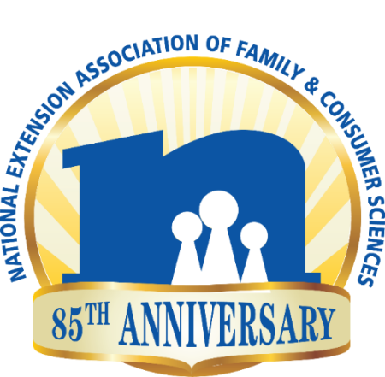
NEAFCS 85th Anniversary Affiliate Report Form
Due to Debby Mathews September 1, 2019
Please send report to emathews@aces.edu
A note from the 85th Anniversary Committee…..
The NEAFCS 85th Celebration is a stepping stone /marker looking toward our 100th Anniversary. Our desire is to celebrate the past while looking toward the future. In fifteen years where will you be? Where will Extension be? How will NEAFCS look/behave? As your affiliate celebrates our 85th Anniversary, review the historical information on the NEAFCS website and contemplate our original mission and objectives. How have these aspects of our association changed? What is the same? What is different? How sustainable is NEAFCS?

Did you have an affiliate 85th Anniversary Chairman/Committee?

How did your affiliate celebrate the 85th?

How did your affiliate use the NEAFCS history/archives information on our website? (Under About NEAFCS) Which resources did you use?

How did you use the NEAFCS Facebook monthly 85th Anniversary tidbits?

How did your affiliate implement the 85 Things to do list as a group /individually?

Additional comments/feedback regarding our 85th Anniversary celebration.

